Restore files on a Storage account (Blob&File)

- Search for the storage account on azure portal
- Navigate to storage account name.
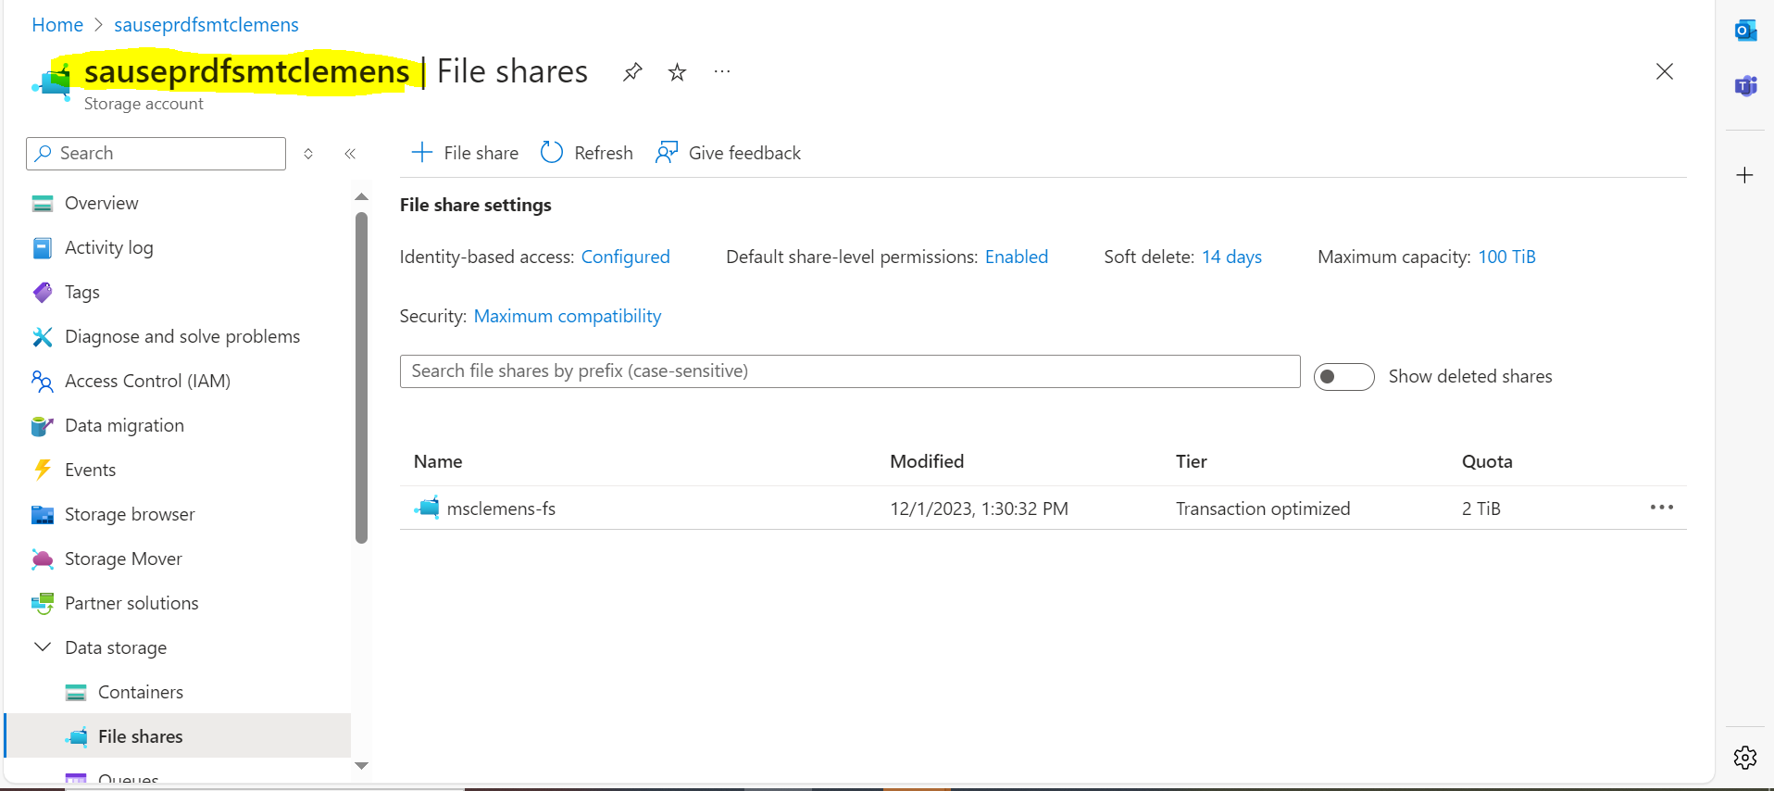

- Go to file share option and click on path mark by yellow colour.
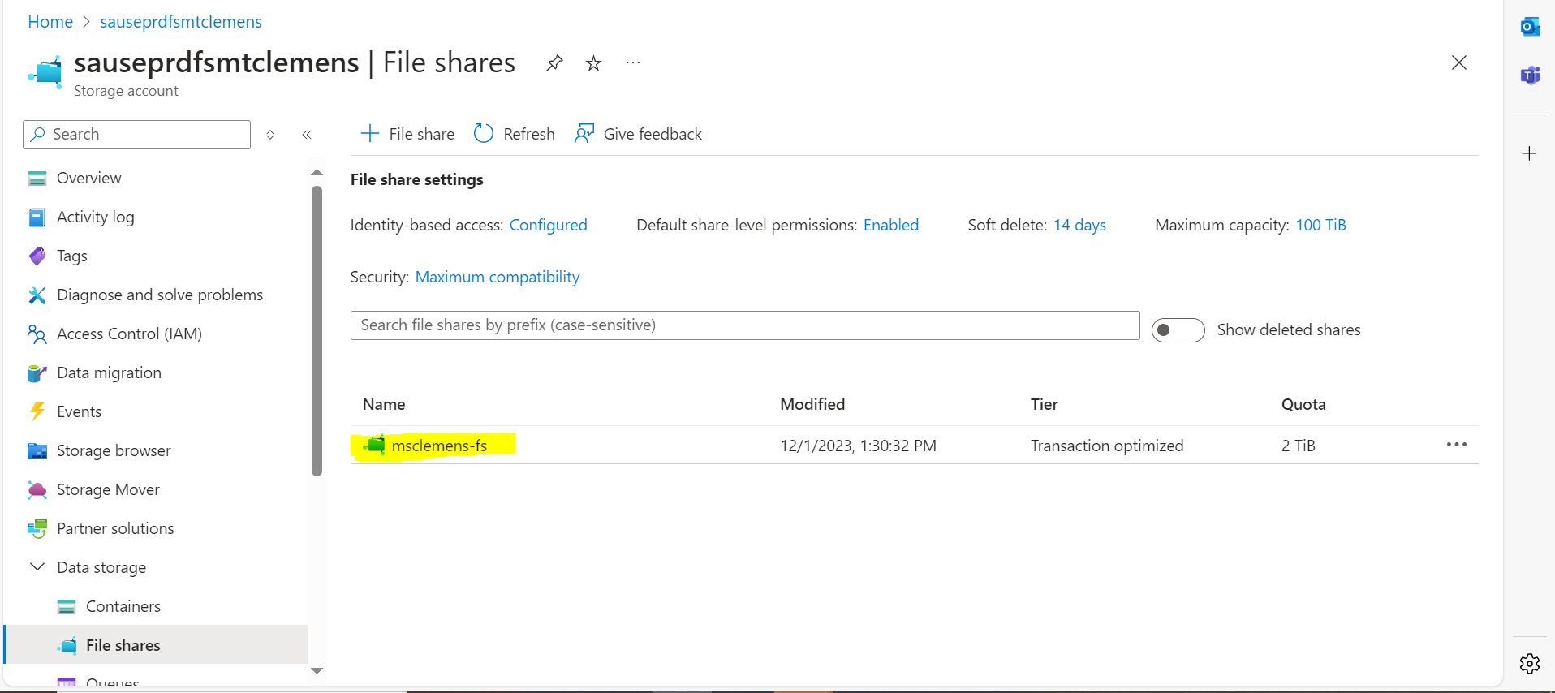

- After clicking on ‘msclemens-fs’ go to backup option.
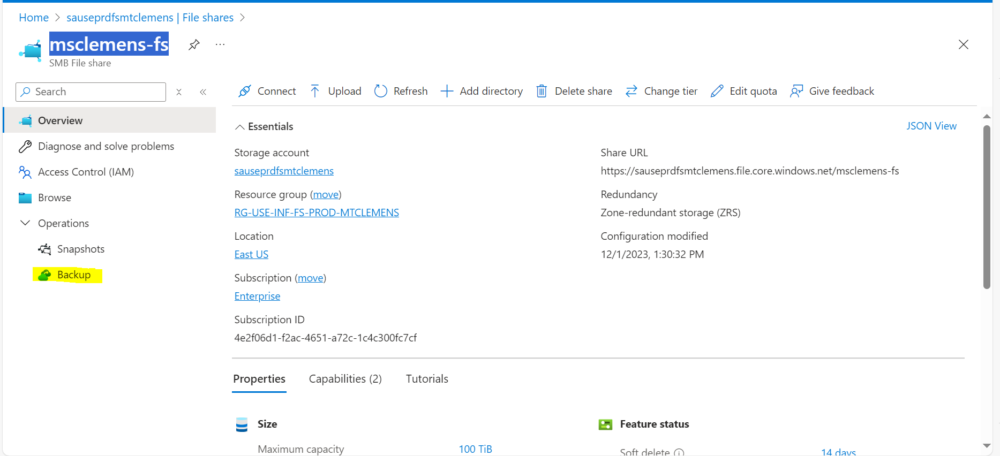

- After clicking on backup option Navigate to file recovery option
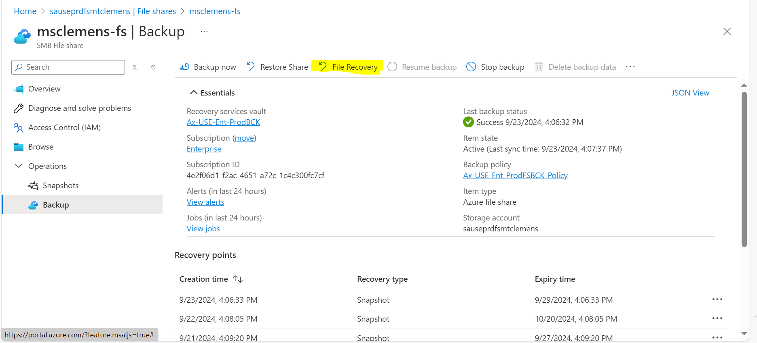

- Now select the restoration date and backup destination.
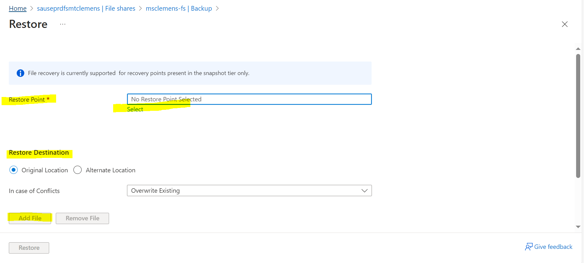

- You can overwrite existing or you can skip as per requirement.
- Now click on restore button and after some time restoration will successful.

